EXPERIMENT V

AIM:

To visualize the Basketball Play-by-Play dataset (pbp2026.csv) using Matplotlib by creating different charts such as line, bar, pie, histogram, scatter, box, and multiple line plots to analyze event patterns, distributions, spatial court metrics, and score relationships among variables.

ALGORITHM:
- Import the required Python libraries: pandas and matplotlib.pyplot.
- Load the Basketball Play-by-Play dataset (pbp2026.csv) into a DataFrame.
- Inspect the dataset and select target columns for visualization (dist, type, result, x, y, h_pts, a_pts).
- Create a line chart to visualize shot distance variations (dist) across initial game records.
- Generate a bar chart to display the counts of the most frequent play-by-play event types.
- Plot a pie chart to show the proportion of shot outcomes (Made vs. Missed).
- Create a histogram to analyze the distribution of shot distance values.
- Draw a scatter plot to examine the relationship between court Y-coordinates (y) and shot distance (dist).
- Generate a box plot to detect spread, central tendency, and outliers in shot distances.
- Create a multiple line chart to compare home team points (h_pts) and away team points (a_pts) over game progression.
- Add appropriate titles, axis labels, and legends to enhance graph readability.
- Display each visualization and interpret the key analytical findings.

PROGRAM : Line Chart
import pandas as pd
import matplotlib.pyplot as plt

# Load dataset
df = pd.read_csv("pbp2026.csv")
print("Dataset loaded successfully for Visualization!")

single_game = df[df["gameid"] == 22500001].dropna(subset=["h_pts"])

plt.figure(figsize=(9, 4.5))
plt.plot(range(len(single_game)), single_game["h_pts"], color="blue", label="Home Score")
plt.title("Home Team Score Progression Over Game Events")
plt.xlabel("Event Index")
plt.ylabel("Points Scored")
plt.grid(True, linestyle="--", alpha=0.6)
plt.legend()
plt.tight_layout()
plt.show()

Output:

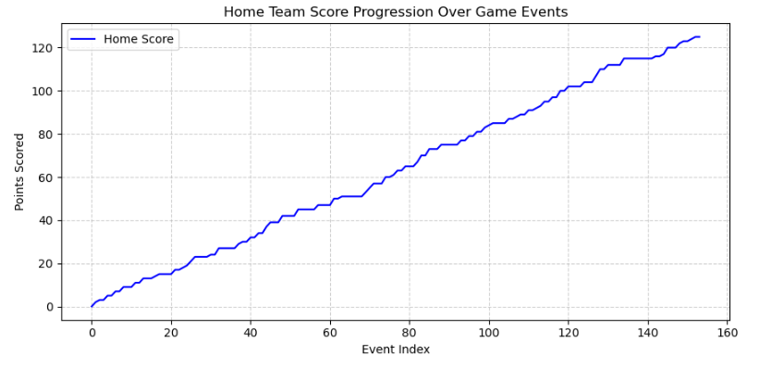

Program: Bar Chart
top_teams = df["team"].value_counts().head(10)

plt.figure(figsize=(9, 4.5))
plt.bar(top_teams.index, top_teams.values, color="royalblue", edgecolor="black")
plt.title("Total Plays Recorded per Team (Top 10)")
plt.xlabel("Team Code")
plt.ylabel("Event Count")
plt.tight_layout()
plt.show()

Output:
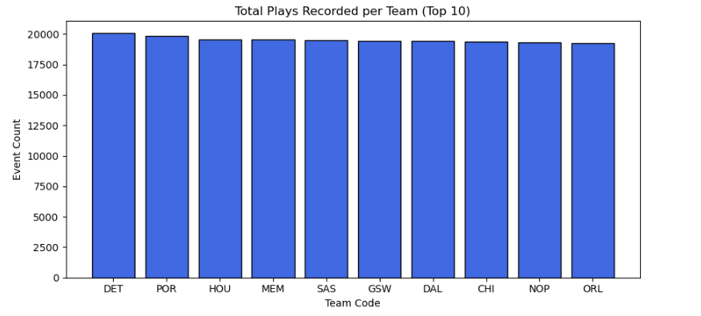

Program: Pie Chart
shot_outcomes = df["result"].value_counts()

plt.figure(figsize=(6, 6))
plt.pie(shot_outcomes.values, labels=shot_outcomes.index, autopct="%1.1f%%",
startangle=140, colors=["#4CAF50", "#FF5722"])
plt.title("Proportion of Made vs. Missed Shots")
plt.tight_layout()
plt.show()

Output:
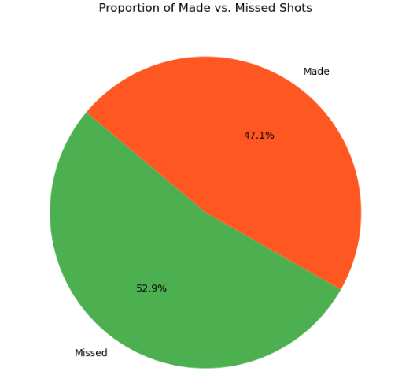

Program: Histogram
valid_distances = df[df["dist"] > 0]["dist"].dropna()

plt.figure(figsize=(9, 4.5))
plt.hist(valid_distances, bins=25, color="purple", edgecolor="black", alpha=0.7)
plt.title("Shot Distance Frequency Distribution")
plt.xlabel("Shot Distance (ft)")
plt.ylabel("Frequency / Count")
plt.tight_layout()
plt.show()

Output:
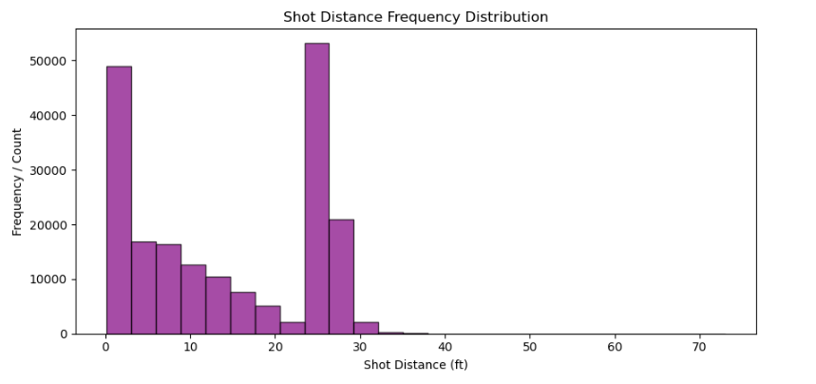

Program: Scatter Plot
sample_shots = df[df["type"].isin(["Made Shot", "Missed Shot"])].sample(1500, random_state=42)

plt.figure(figsize=(8, 6))
plt.scatter(sample_shots["x"], sample_shots["y"], alpha=0.4, c="darkcyan", s=20)
plt.title("Scatter Plot of Court Shot Locations (X vs. Y)")
plt.xlabel("Court X Coordinate")
plt.ylabel("Court Y Coordinate")
plt.grid(True, linestyle=":", alpha=0.5)
plt.tight_layout()
plt.show()

Output:
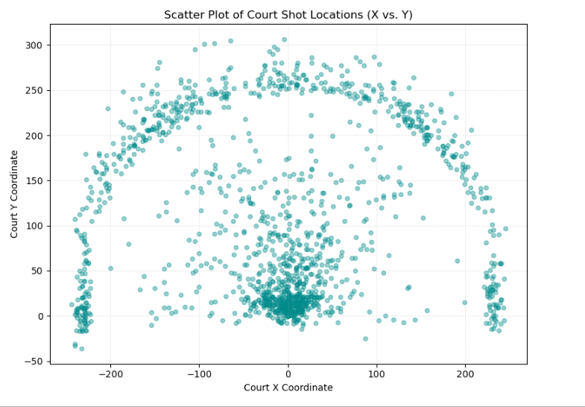

Program: Box Plot
plt.figure(figsize=(8, 4))
plt.boxplot(valid_distances, vert=False, patch_artist=True,
boxprops=dict(facecolor="lightblue", color="blue"))
plt.title("Box Plot of Shot Distances (Outlier Detection)")
plt.xlabel("Distance (ft)")
plt.tight_layout()
plt.show()

Output:

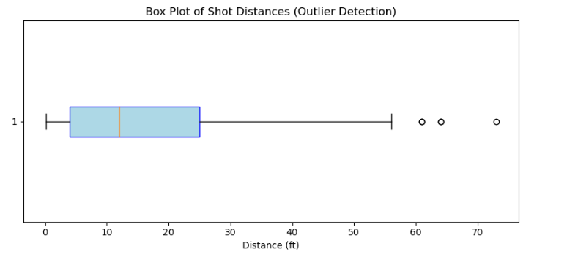

Program: Multiple Line Chart
game_data = df[df["gameid"] == 22500001].dropna(subset=["h_pts", "a_pts"])

plt.figure(figsize=(10, 5))
plt.plot(range(len(game_data)), game_data["h_pts"], label="Home Team", color="blue", linewidth=2)
plt.plot(range(len(game_data)), game_data["a_pts"], label="Away Team", color="red", linewidth=2)
plt.title("Home vs Away Score Comparison (Game 22500001)")
plt.xlabel("Event Index")
plt.ylabel("Cumulative Points")
plt.legend(loc="upper left")
plt.grid(True, linestyle="--", alpha=0.5)
plt.tight_layout()
plt.show()

Output:
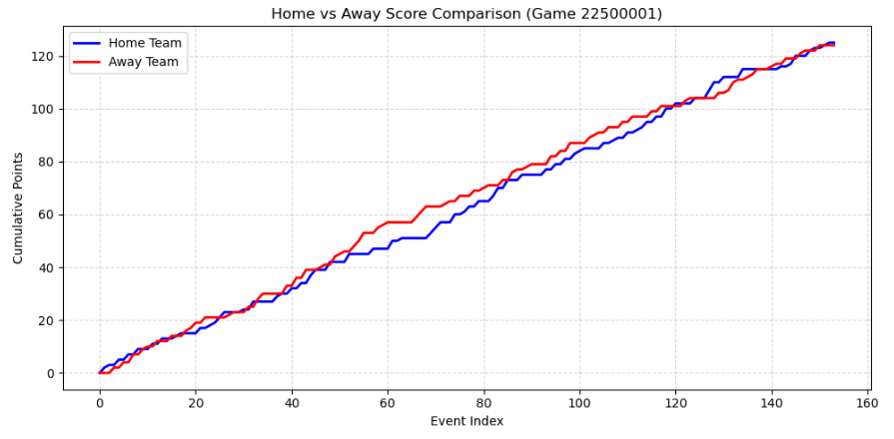

Result:
The Basketball Play-by-Play dataset (pbp2026.csv) was successfully visualized using various Matplotlib charts. Different visualization techniques helped analyze event distribution, shot outcome ratios, spatial court coordinates, score progression, and relationships between variables. The graphs also highlighted structural trends and potential outliers in the dataset. These visualizations provided meaningful insights for exploratory data analysis and play-by-play game pattern evaluation.

